1.1 MỤC D.4 — PHÁC THẢO GIAO DIỆN (WIREFRAME / MOCKUP)
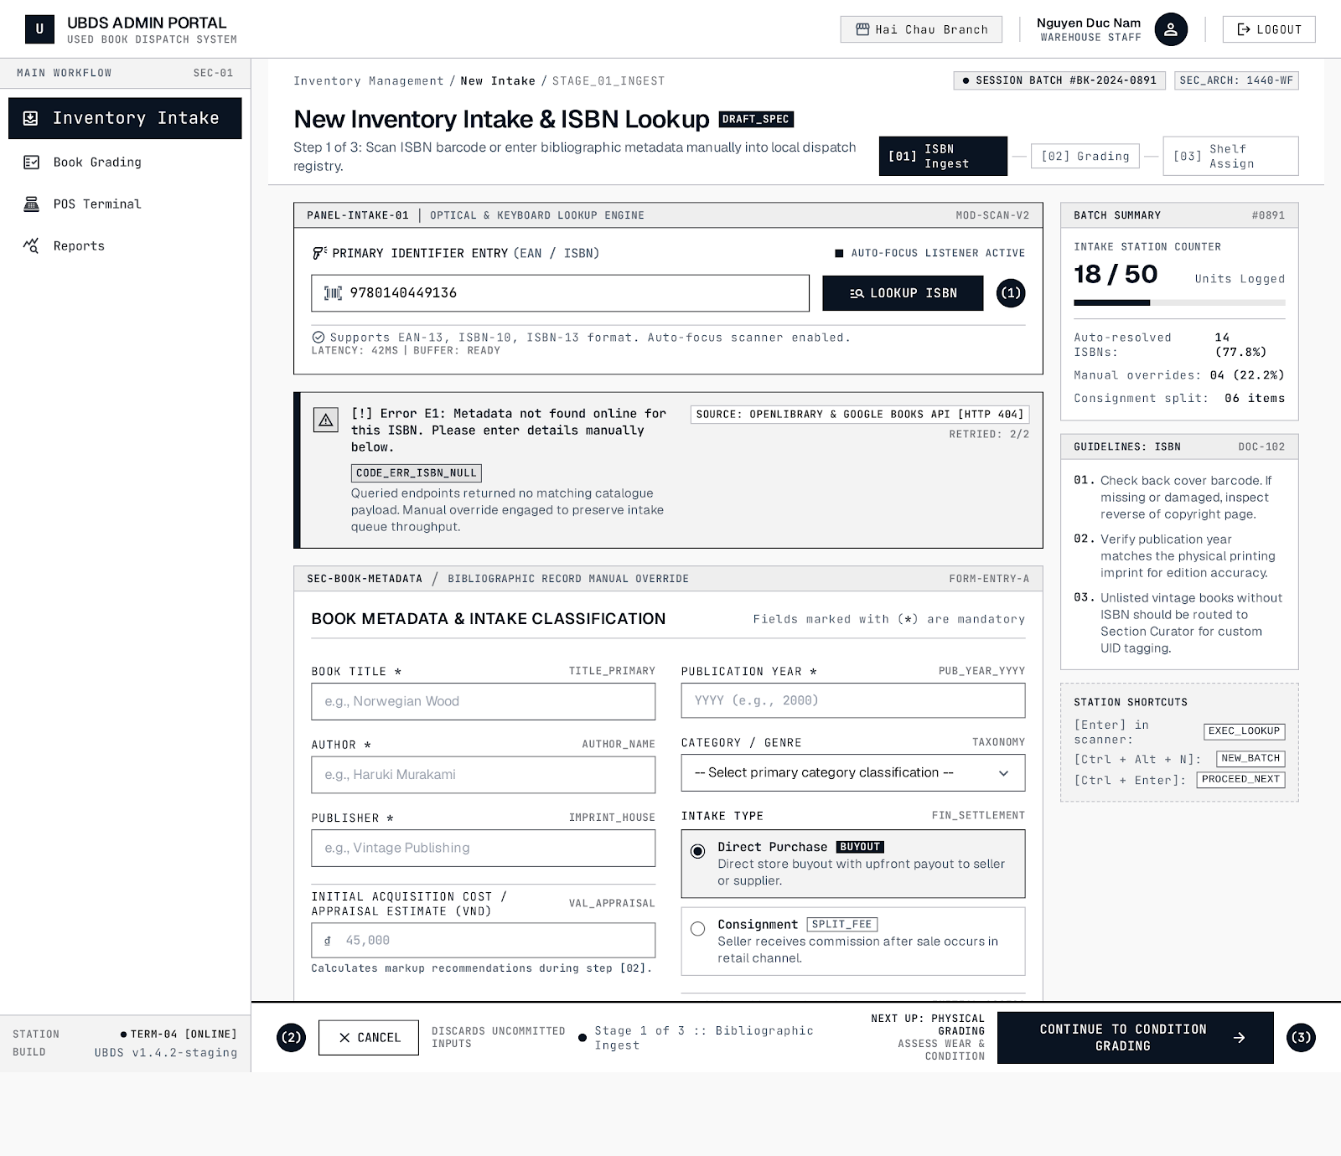
Hình 1 SCR-01 Màn hình tiếp nhận và tra cứu mã vạch ISBN

# | Element Name | Control Type | Data Source | Mandatory | Constraints / Validation Rules | Associated System Action
1 | ISBN Barcode Input | Textbox | Barcode scanner / Keyboard | Yes | Exactly 10 or 13 digits; numeric only | Triggers background API metadata lookup (Callout ①)
2 | "Lookup ISBN" Button | Button | — | No | Enabled when text is keyed in | Dispatches query to external ISBN Data Service
3 | Error Alert Banner | Alert Banner | System-generated | No | Displayed on API timeout or ISBN not found | Prompts manual data entry fallback (Exception E1)
4 | Book Title | Textbox | External API / Manual entry | Yes | Max 255 chars; cannot be blank | Persisted to database Title field
5 | Author(s) | Textbox | External API / Manual entry | Yes | Max 150 chars | Persisted to database Author field
6 | Publisher | Textbox | External API / Manual entry | Yes | Max 150 chars | Persisted to database Publisher field
7 | Publication Year | Textbox (Number) | External API / Manual entry | Yes | Integer <= current year (2026) | Persisted to database PublicationYear field
8 | Category / Genre | Dropdown list | System catalog configuration | Yes | Must select a valid preset genre | Categorizes book for pricing recommendation engine
9 | Intake Classification | Radio button group | Default: "Direct Purchase" | Yes | Binary choice: Direct Purchase / Consignment | Determines commission calculation workflow (UC-07)
10 | "Cancel Intake" Button | Button | — | No | Requires confirmation modal | Discards input draft and clears form (Callout ②)
11 | "Proceed to Grading" Button | Button | — | Yes | Enabled only when all mandatory (*) fields are filled | Navigates to Screen SCR-02 (Callout ③)

1.2 Màn hình SCR-02: Thẩm định tình trạng 5 bậc & Định giá bán
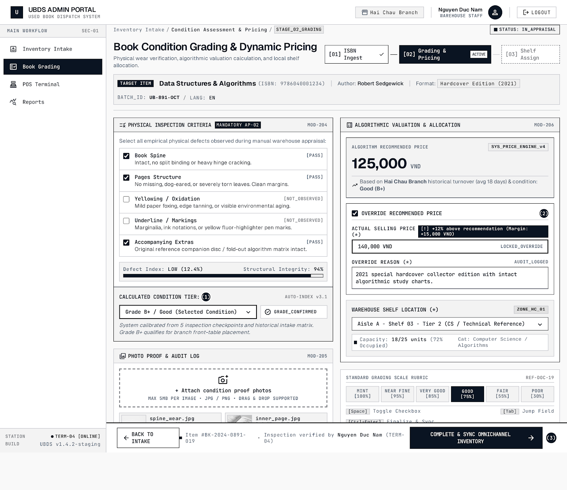
Hình 2-SCR-02 Màn hình thẩm định tình trạng 5 bậc và định giá bán

# | Element Name | Control Type | Data Source | Mandatory | Constraints / Validation Rules | Associated System Action
1 | 5-Tier Inspection Checklist | Checkbox list | UBDS standardized criteria | Yes | All criteria items must be reviewed | Serves as raw heuristic input for condition grading
2 | Suggested Condition Tier | Dropdown list | 5 values: New, Very Good, Good, Acceptable, Poor | Yes | Constrained strictly to standard 5 tiers (BR-01) | Stores verified ConditionTier on record (Callout ①)
3 | Proof Photo Upload | File Upload | Digital camera / Webcam | Optional | Formats: JPG/PNG; max 5 MB per image | Uploads image to CDN and binds URLs to item (UC-06)
4 | Recommended Price | Label (Read-only) | Dynamic Pricing Assistant engine | Yes | Integer format >= 0 VND | Serves as market baseline reference (UC-08)
5 | "Override Price" Checkbox | Checkbox | Staff toggle | No | Default: Unchecked | Toggles editable state for fields #6 and #7 (Callout ②)
6 | Actual Selling Price | Textbox (Number) | Manual staff input | Yes | Integer > 0; multiple of 1,000 VND | Stores official listing SellingPrice attribute
7 | Override Reason | Textbox | Manual staff input | Yes (if #5 checked) | Min 10 chars; justification required | Logs audit trail and triggers Store Manager alert (UC-09)
8 | Shelf Location Code | Dropdown list | Physical warehouse grid layout | Yes | Must select an available shelf slot | Assigns physical coordinate ShelfLocation
9 | "Complete & Sync" Button | Button | — | Yes | Enabled once all mandatory fields are verified | Sets status to Available & triggers sync (Callout ③)

2
2.1
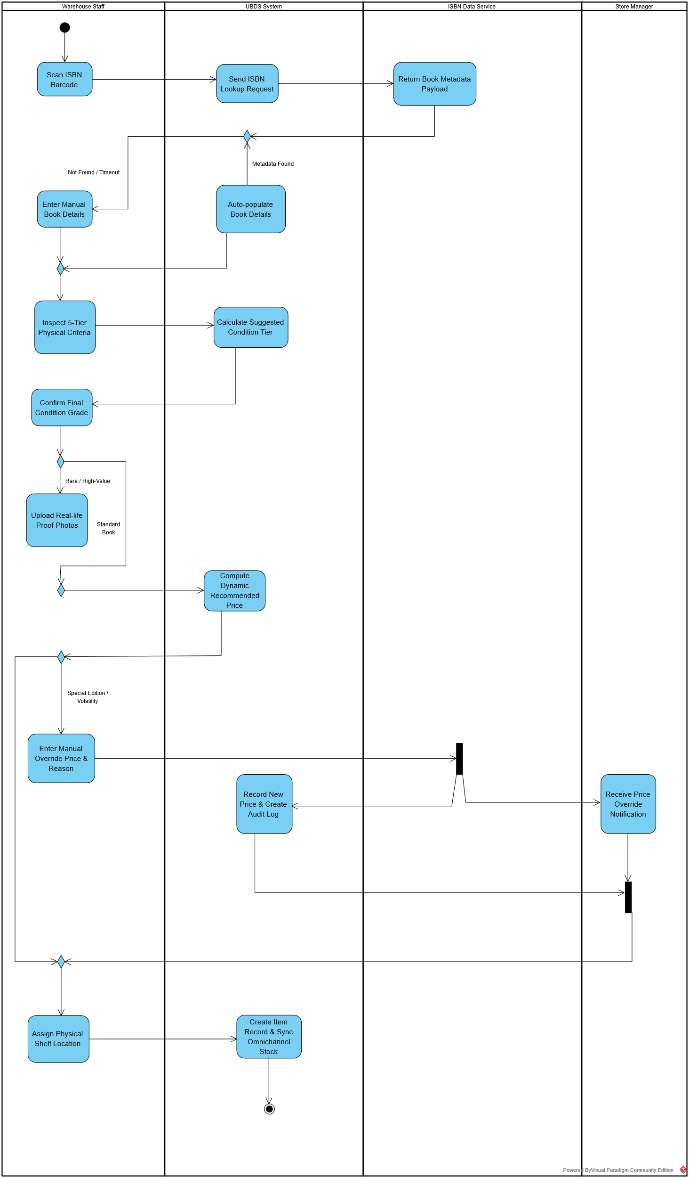

2.2 Bảng mô tả chi tiết luồng sự kiện (Activity Flow Table):
Step | Partition (Swimlane) | Business Action / Event | Branching Guard | Output Artifact / Result
1 | Warehouse Staff | Scan physical book ISBN barcode | — | ISBN query string captured
2 | UBDS System | Dispatch metadata lookup request | — | Outbound API HTTP request
3 | ISBN Data Service | Return metadata payload | — | JSON response (Title, Author, Pub)
4a | UBDS System | Auto-populate intake form fields | [Metadata found] | Pre-filled book profile
4b | Warehouse Staff | Enter book details manually | [Not found / Timeout] | Manual metadata saved
5 | Warehouse Staff | Inspect 5-tier physical criteria checklist | — | Checked criteria input
6 | UBDS System | Calculate suggested condition tier | — | Recommended grading tier
7 | Warehouse Staff | Confirm final condition grade | — | Verified ConditionTier
8a | Warehouse Staff | Upload real-life proof photos | [Rare / High-value] | Photo URLs attached
8b | Warehouse Staff | Skip photo capture step | [Standard book] | Flow advances to pricing
9 | UBDS System | Compute dynamic recommended price | — | Calculated base price
10a | Warehouse Staff | Accept system suggested price | [Accept price] | Final price confirmed
10b | Warehouse Staff | Enter manual override price & reason | [Market volatility / Special edition] | Override price recorded
11 | Store Manager | Receive price override alert notice | [Parallel fork branch] | Audit log notification
12 | Warehouse Staff | Assign physical shelf location code | — | Shelf location linked
13 | UBDS System | Save item & sync omnichannel stock | — | Item status set to Available

3
3.1 Bảng chuyển trạng thái (State Transition Table)
Current State | Trigger Event | Guard Condition | Action Executed | Next State
● (Initial) | Start Intake | — | Initialize temporary draft record | Draft
Draft | Scan ISBN & Inspect | [Valid Checklist] | Assign 5-tier condition grade | Graded
Draft | Cancel Intake | [Damaged / Invalid] | Delete intake record | ◉ (Final)
Graded | Confirm Price & Shelf | [Shelf Assigned] | Sync omnichannel stock | Available
Available | POS Checkout | [Payment Success] | Print receipt & deduct stock | Sold
Available | Online Order Placed | [In Stock] | Hold inventory temporarily | Reserved
Reserved | Online Payment Success | [Before 15 Mins] | Confirm order | Sold
Reserved | Payment Timeout | [After 15 Mins] | Release held stock | Available
Sold | Archive | — | Close transaction record | ◉ (Final)

3.2


